New topology: [laptop NB with RJ45 and fixed IP=192.168.1.3 mask 255.255.255.0 gateway=192.168.1 DHCP disabled] Ethernet cable [‘LAN’ port of Router AG-PRO-INS fixed IP=192.168.1.2 mask 255.255.255.0 gateway=192.168.1.1 (4G Wi-Fi modem/1st router Digma DW1961 as a access point)] wireless connection in transparent bridge mode +arpNAT [4G Wi-Fi modem/router fixed IP=192.1.68.1.1 DHCP enabled for its wireless client only but it’s not nessesary for my purpose]
Ag-Pro-INS

NB

Digma

192.168.1.3 Eth 192.168.1.2 Wi-Fi bridge 192.168.1.1
AG-PRO-INS powered by microUSB cable and power supply 5V 2A.
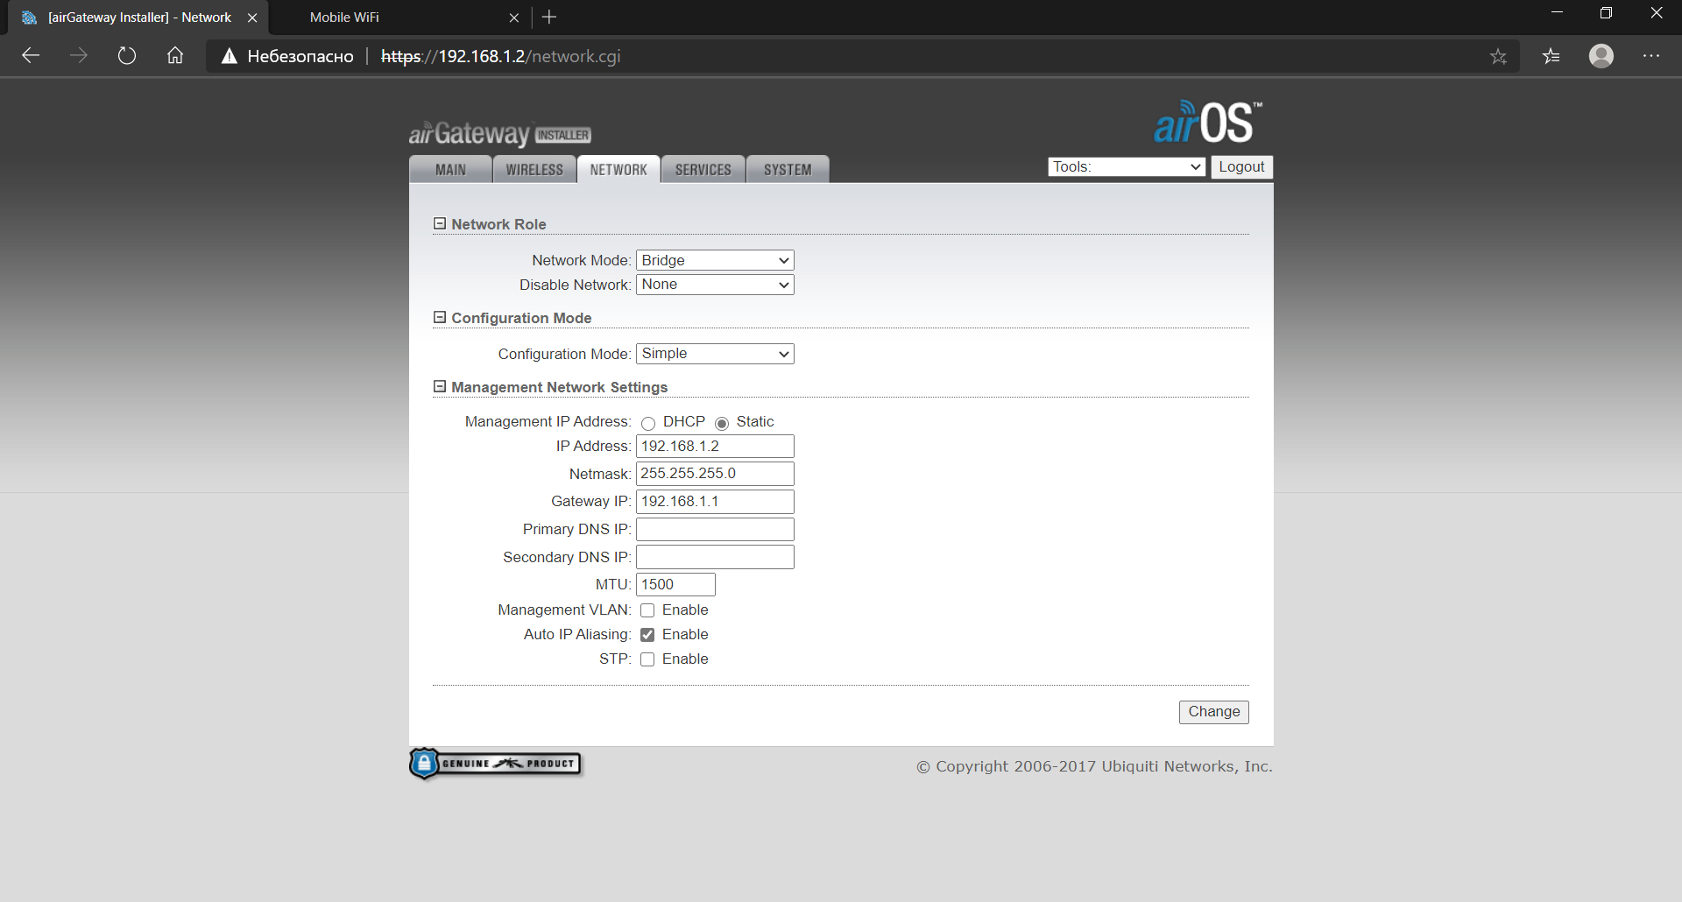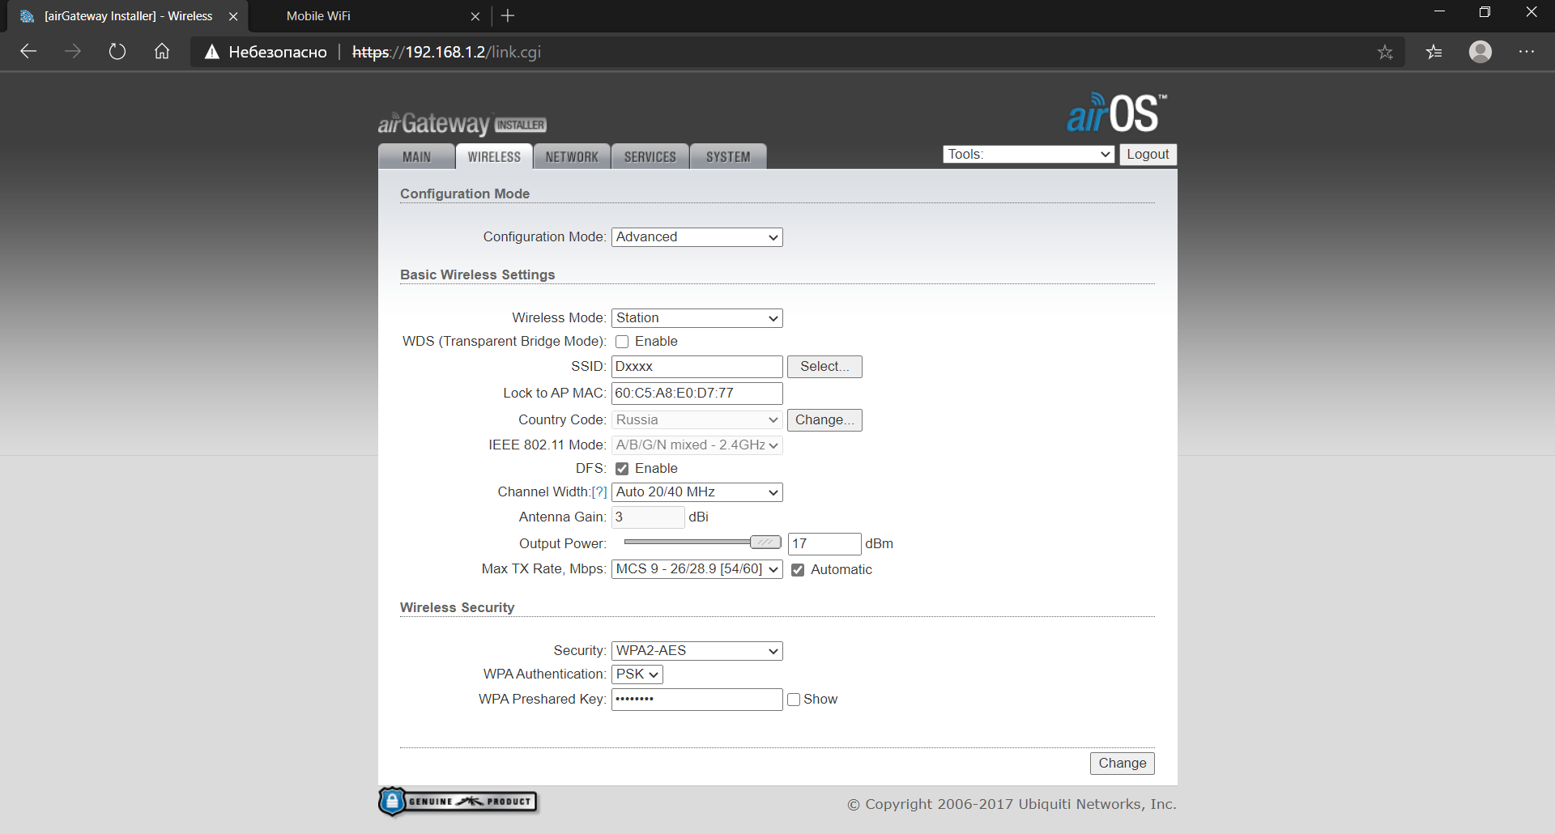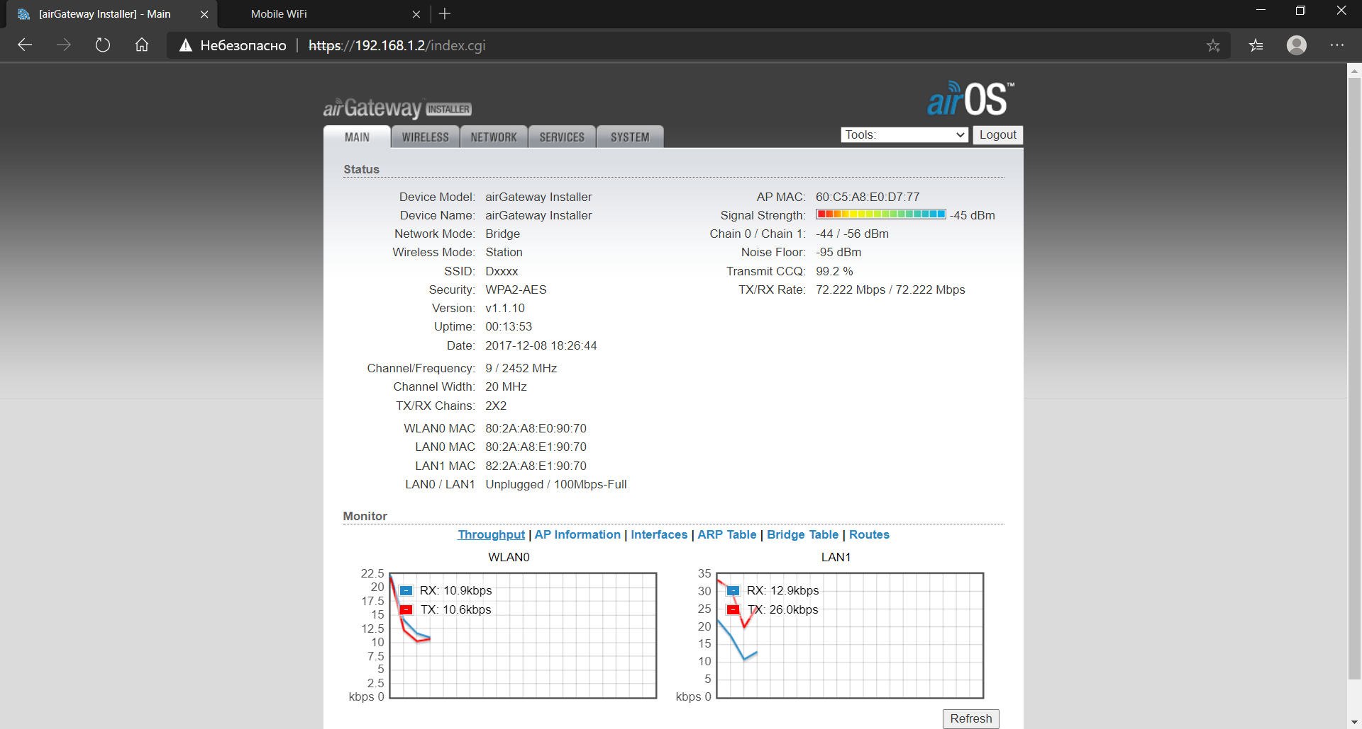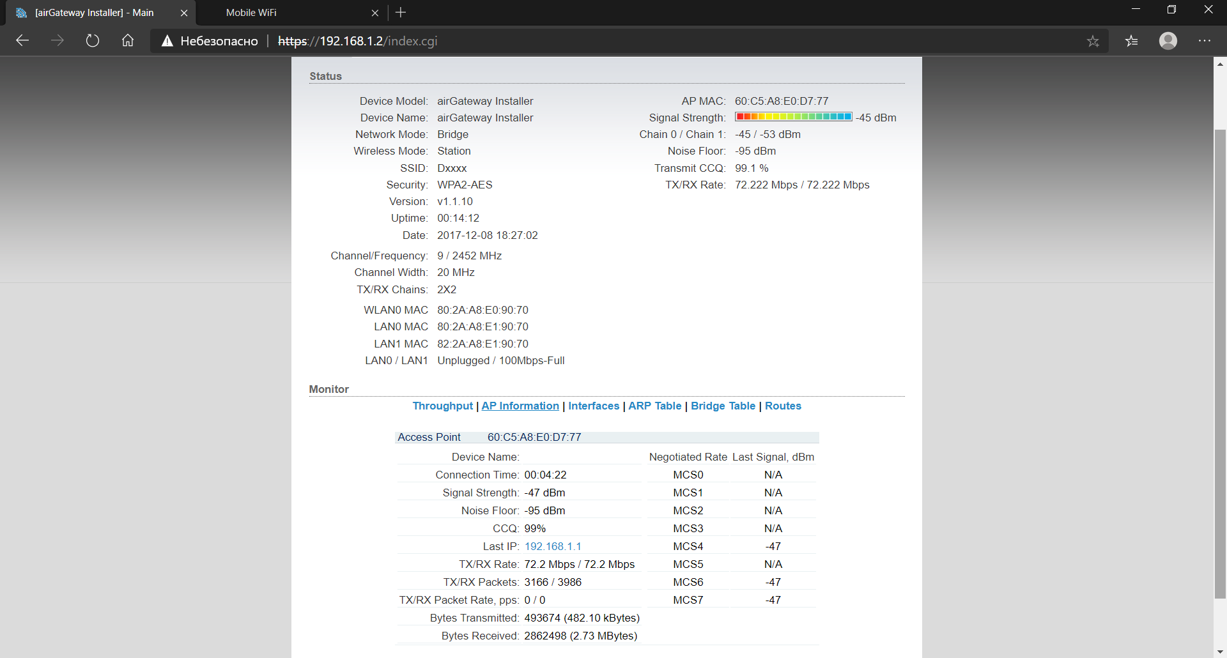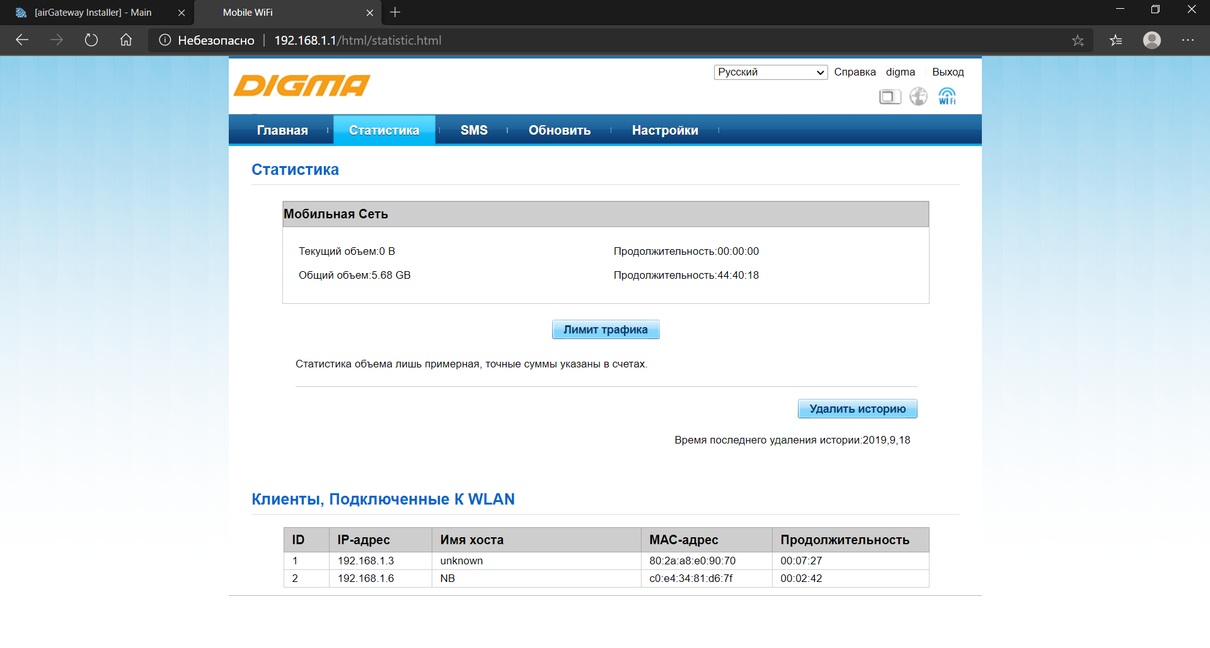
192.168.1.6 is a separate additional wireless connection to modem from laptop in order to simple check number of connections.
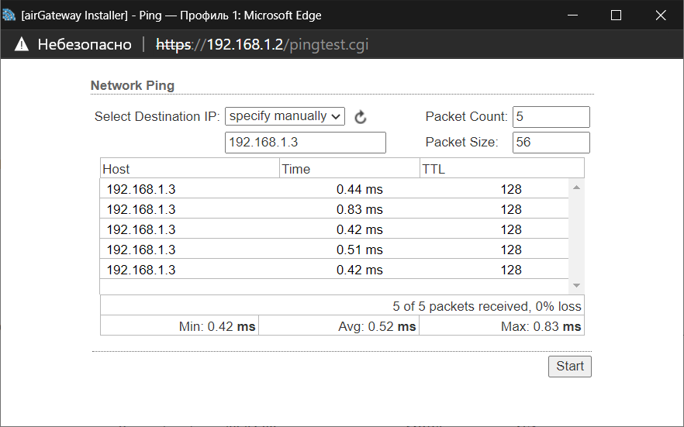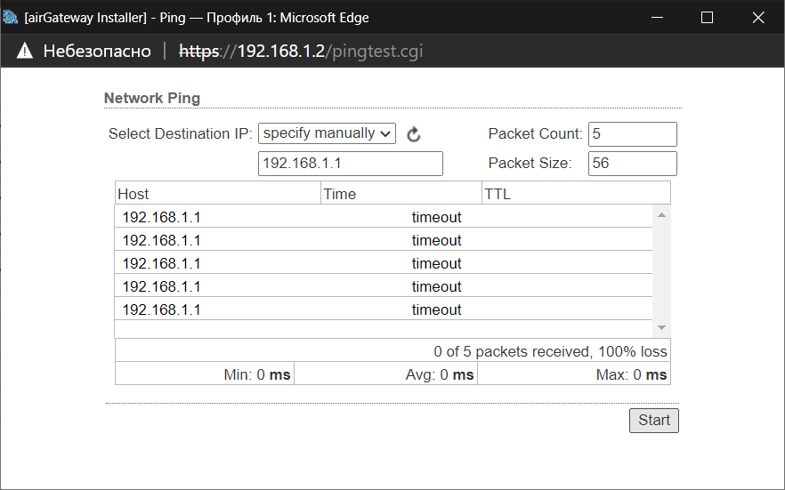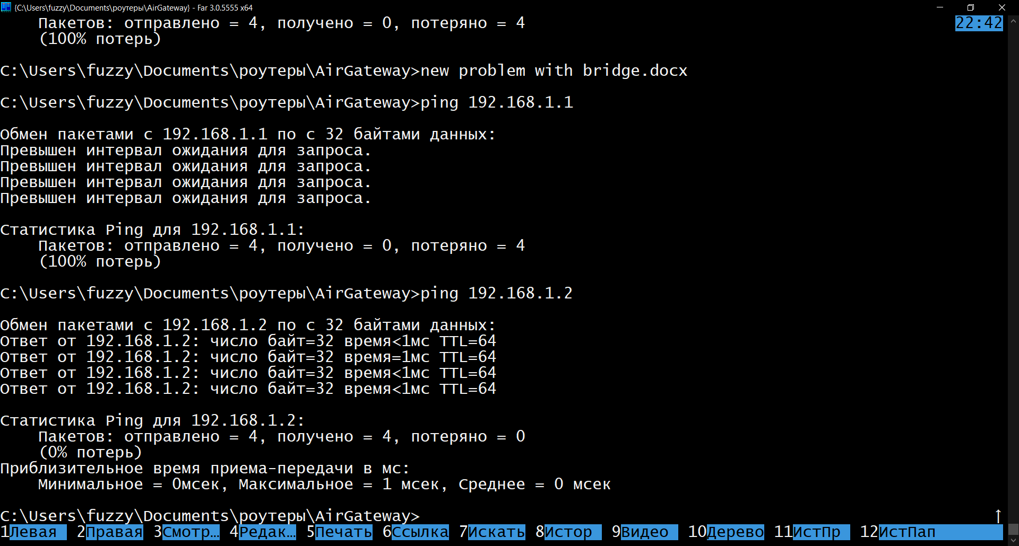

Settings on the laptop:
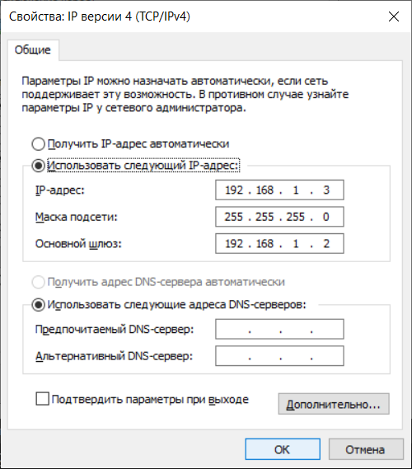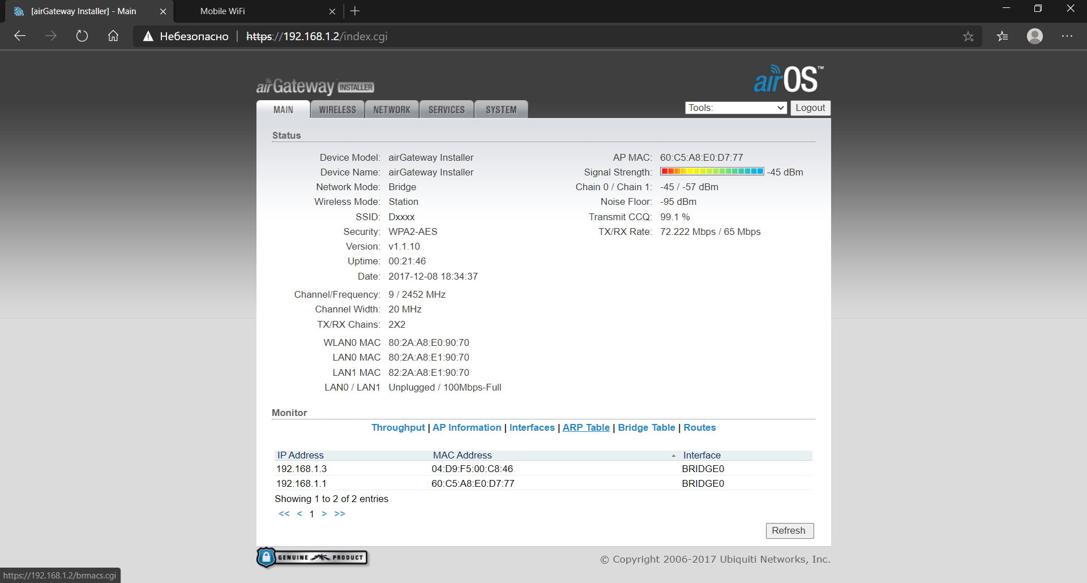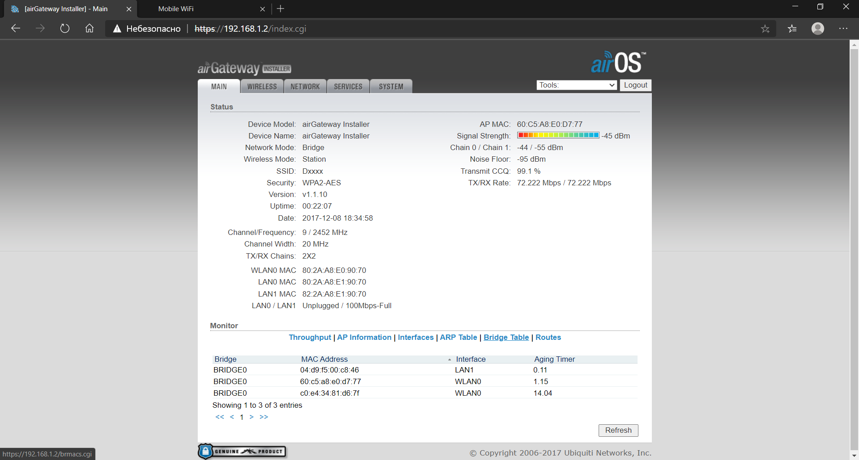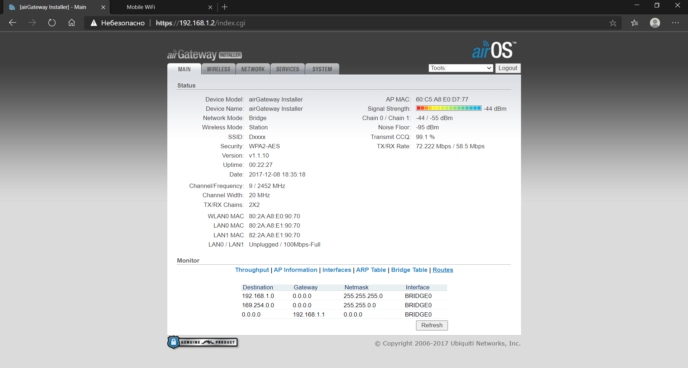
Then having disconnected on Wi-Fi from a laptop to modem I could still come from a laptop on the modem (its address 192,168,1,1) probably through the bridge of AG-Pro-INS: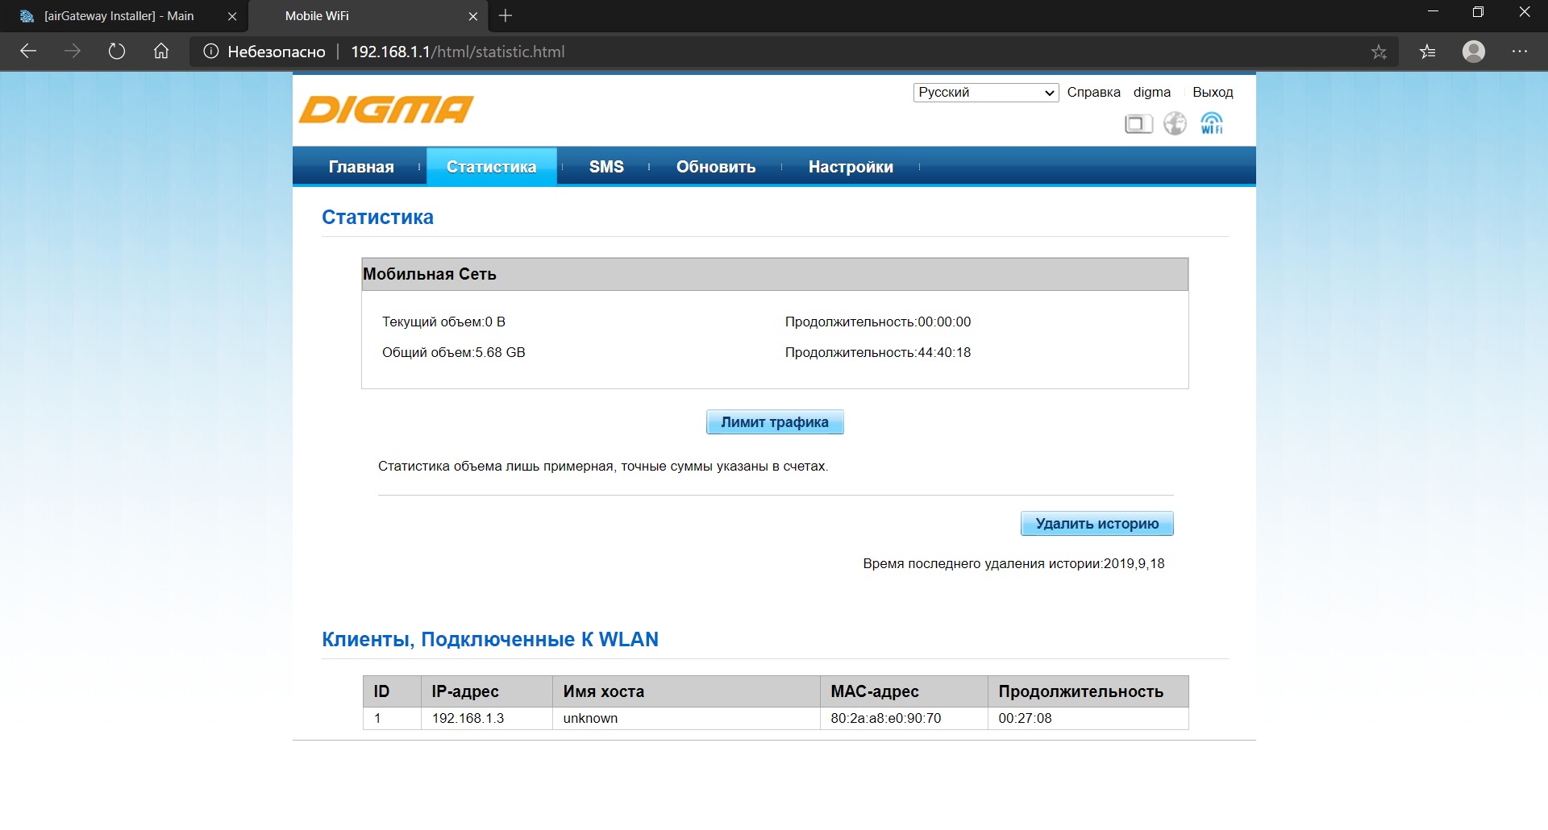
The main question. May scheme above be a guarantee of delivery to the laptop (AHD DVR in future) the mobile Internet coming to the modem?

